

# Final Project

**Graphics and Animation Tools - Lab**

**CSGG 4101**

Name – Rishank Gupta

Roll No. – R100217062

Sap id – 500062486

Course – B. Tech CSE-OSS

Batch – 2

*Under the guidance of…*

Dr.Durgansh Sharma

Associate professor

Department of Cybernetics

School of Computer Science(SOCS)

**Final Project**

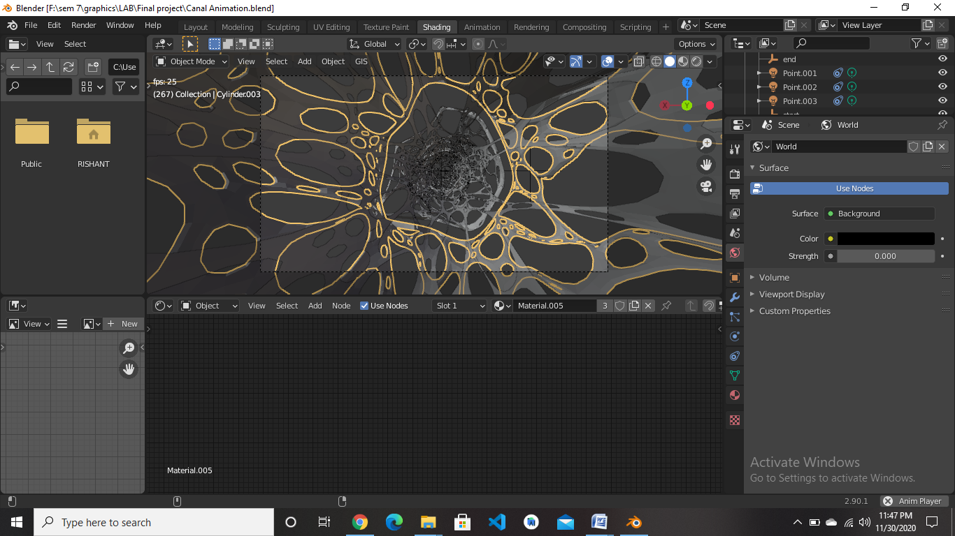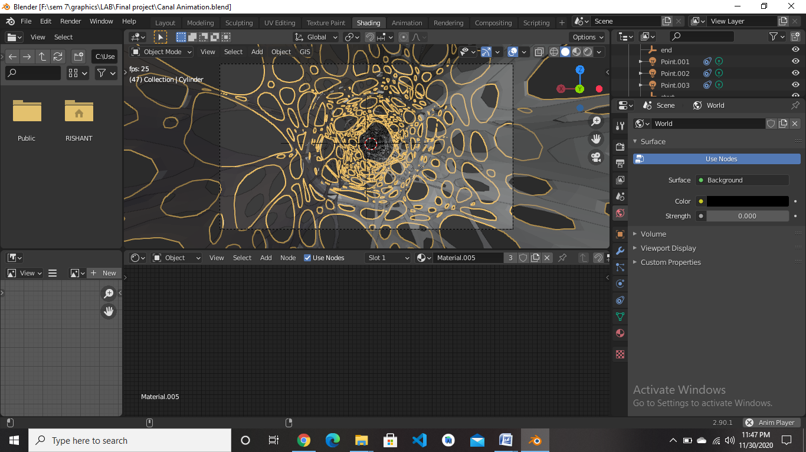

**Link:** [**https://drive.google.com/drive/folders/13HtA0VSQ9N6ythSR7zfFFWX1AuzayOOP?usp=sharing**](https://drive.google.com/drive/folders/13HtA0VSQ9N6ythSR7zfFFWX1AuzayOOP?usp=sharing)